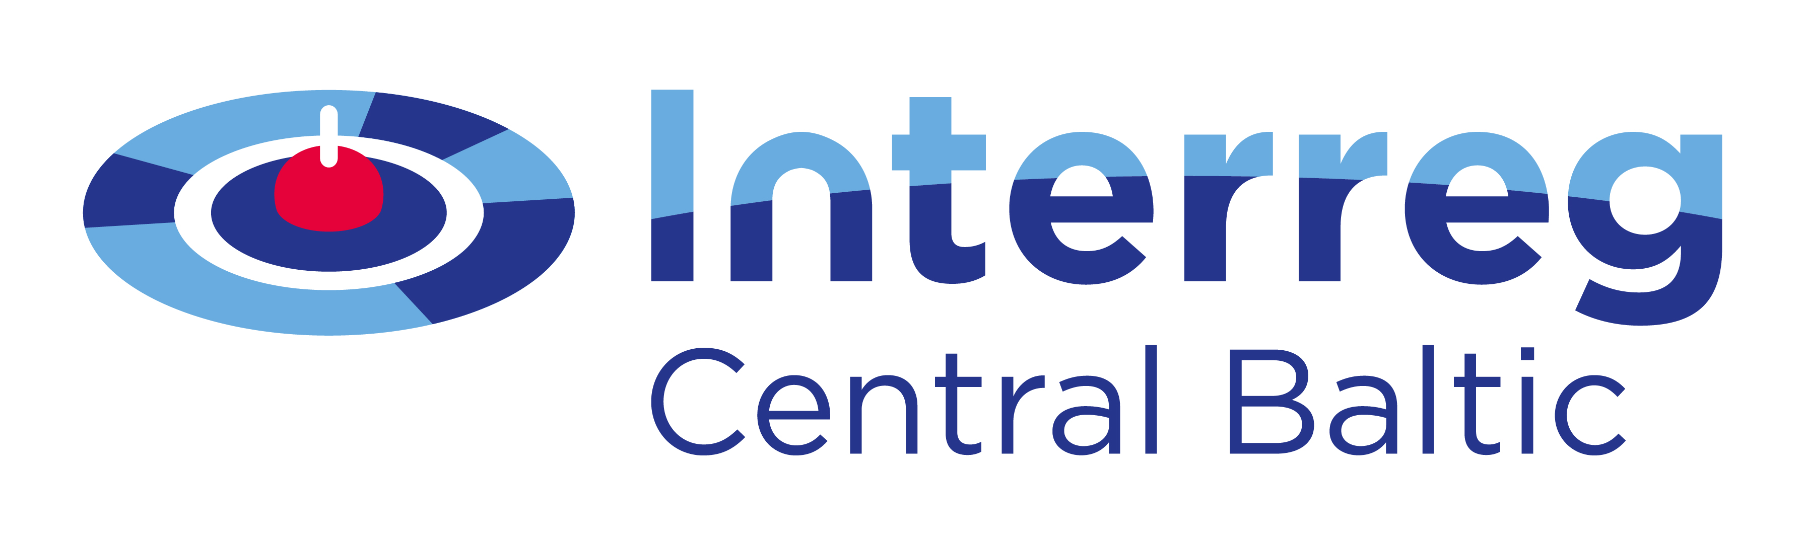 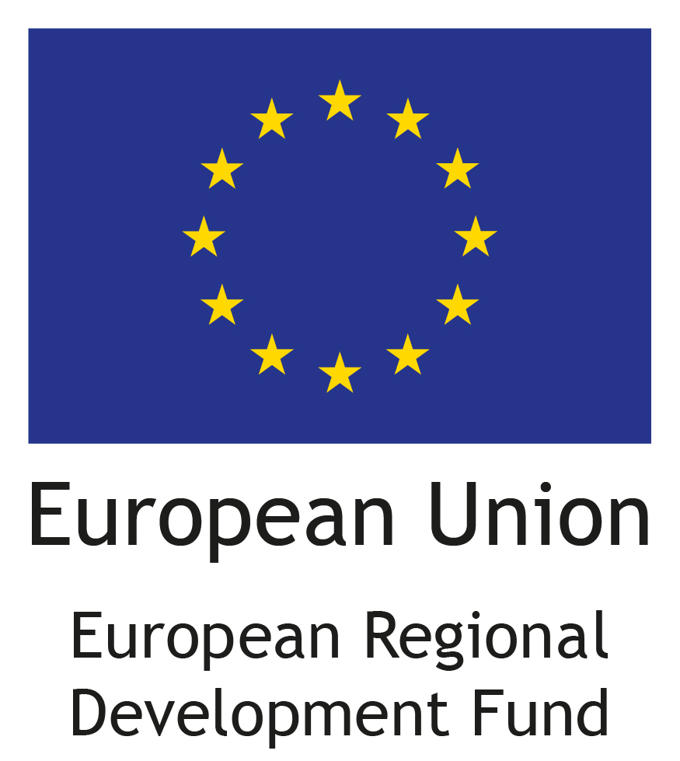 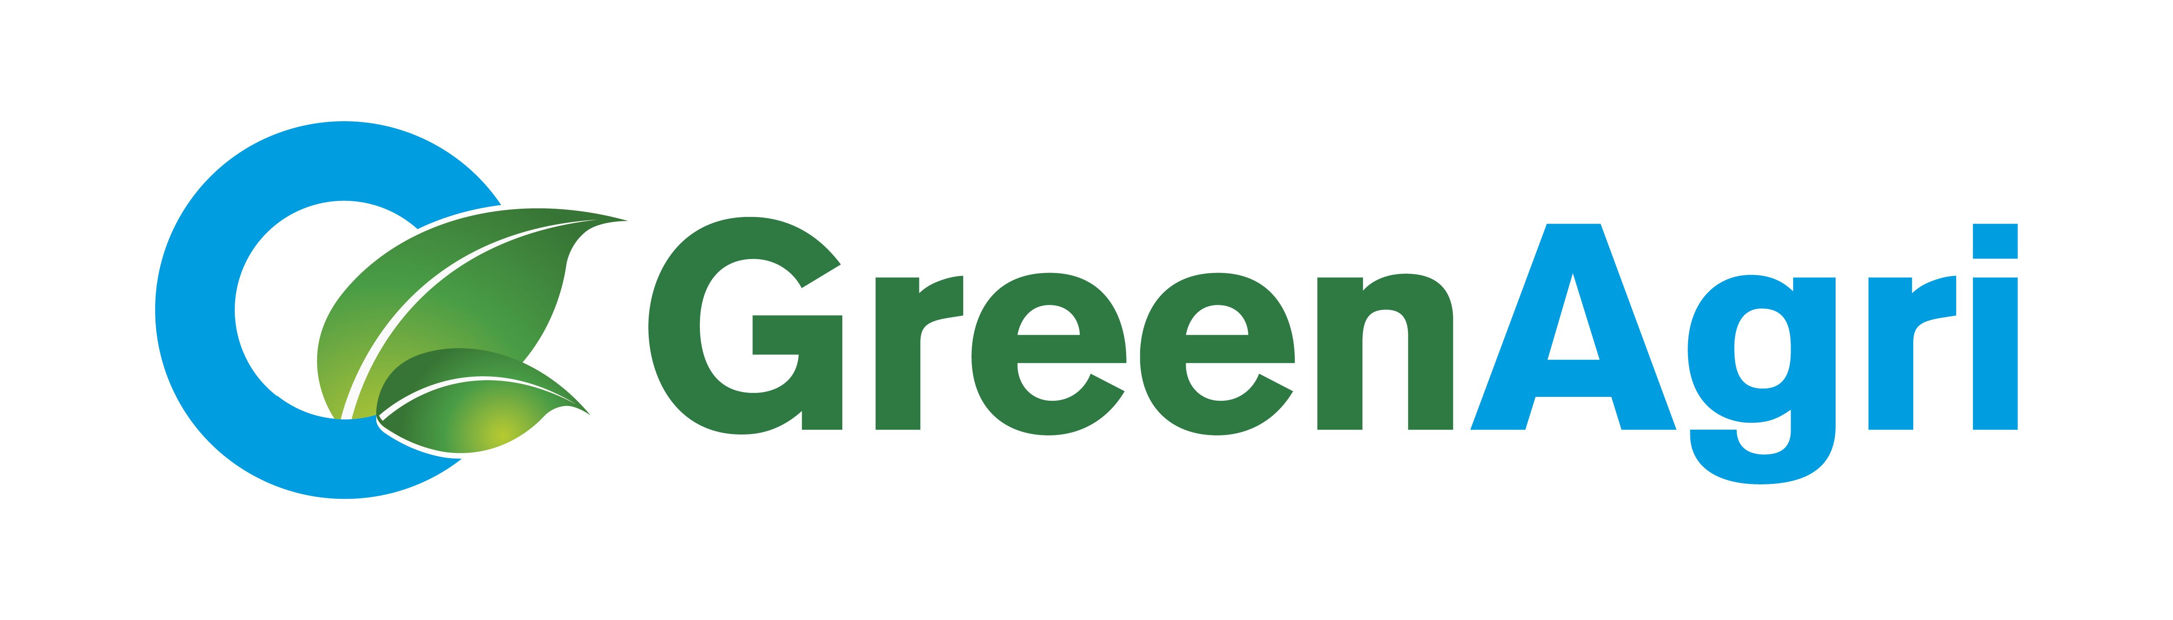

**Seminar for agricultural advisors and enviromental experts**

Program

15-16st November, 2016

Hotel “Dorpat” seminar room “Krause”, Tartu, Estonia

|  |  |
| --- | --- |
| **Tuesday, 15.11.2016.** hotel “Dorpat”, seminar room “Krause” | |
| 12:00-13:00 | Lunch, hotel “Dorpat”, Tartu |
| 13:00 – 14:30 | **New EU-legislation affects use of nitrogen in agriculture** – Ivan Brendstrup, Farmer Focus Manager, BASF |
| 14:30 – 15:00 | Coffee break |
| 15:00 – 16:30 | **Danish legislation and use of N-inhibitores in Agriculture** - Ivan Brendstrup, Farmer Focus Manager, BASF |
| 16:30-17:00 | Discussion |

|  |  |
| --- | --- |
| **Wendsday, 16.11.2016** hotel “Dorpat”, seminar room “Krause” | |
| 9:00 – 11:15 | **Role of soil biota in arable ecosystem** – Merrit Shankiy, Estonian University of Life Sciences |
| 11:15 – 11:45 | Coffee break |
| 11:45 – 12:30 | **Greenhouse gas emissions from agricultural fields** – Jordi Escuer, Estonian University of Life Sciences |
| 12:30 – 13:30 | Lunch, hotel “Dorpat” |
| 13:30 – 15:00 | **Does humus exists? Importance of soil organic matter** – Alar Astover, Estonian University of Life Sciences |
| 15:00 – 15:15 | Coffee break |
| 15:15 – 16:30 | **Nitrogen cycling in agricultural soil – from basic processes to applied examples** – Alar Astover, Estonian University of Life Sciences |

*Seminar is organized in the framework of* *project “GreenAgri”CB272 and partly financed by* the Central-Baltic Programme 2014-2020  *and Union “Farmers Parliament”.*

|  |  |
| --- | --- |
| [Eesti Põllumajandus-Kaubanduskoda](http://www.epkk.ee) |  |